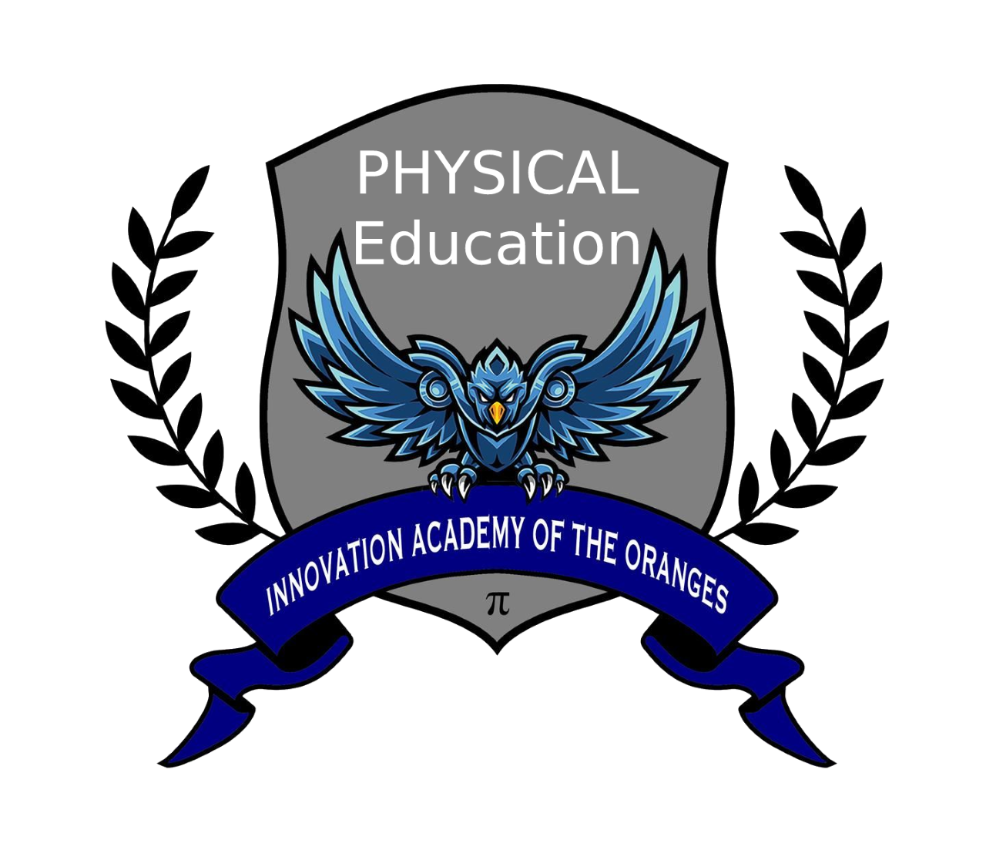

***Course****: Physical Education I, II, III, IV,*

***Meeting Place:*** *Gymnasium*

***Instructors:*** *Mr Roy Hinchman*

Each student will receive a copy of the full syllabus at the beginning of the year, that must be signed and returned. Until then here is a copy of the dress code for ALL students.

***COURSE DESCRIPTION:***

This course provides opportunities for the study of skills, strategies, and developmentally appropriate activities for team and individual sports, and fitness and wellness concepts. I expect **all** students to participate and put forth their best effort and anything short of these expectations will lower your grade.

***DRESS CODE:***

Sneakers, **STEM issued with logo** shorts, sweat-pants, tee-shirts are mandatory.

*For more specifics, please refer to the STEM Student/Parent Handbook*

***ABSOLUTELY NO****:*

Sneakers that do not lace up (crocs or uggs, or similar style) boots or sandals, hoop earrings, bracelets, chains, necklaces or exposed jewelry, pajama pants, capri’s, jeans, hoodies, do-rags, and shirts such as tank-tops, or tee-shirts with inappropriate writing or lack of coverage.

***NO CELL PHONES***

*ALL Health classes will be held in MP2, information will be posted at a later time